**CSA1518-CLOUD COMPUTING**

S.Thrinathr Sai 192011257

**Expt:06**

Demonstrate virtualization by Installing Type-2 Hypervisor in your device, create and configure VM image with a Host Operating system (Either Windows/Linux).

**IMPLEMENTATION:**

STEP 1: DOWNLOAD VMWARE WORKSTATION AND INSTALLED AS TYPE 2 HYPERVISOR

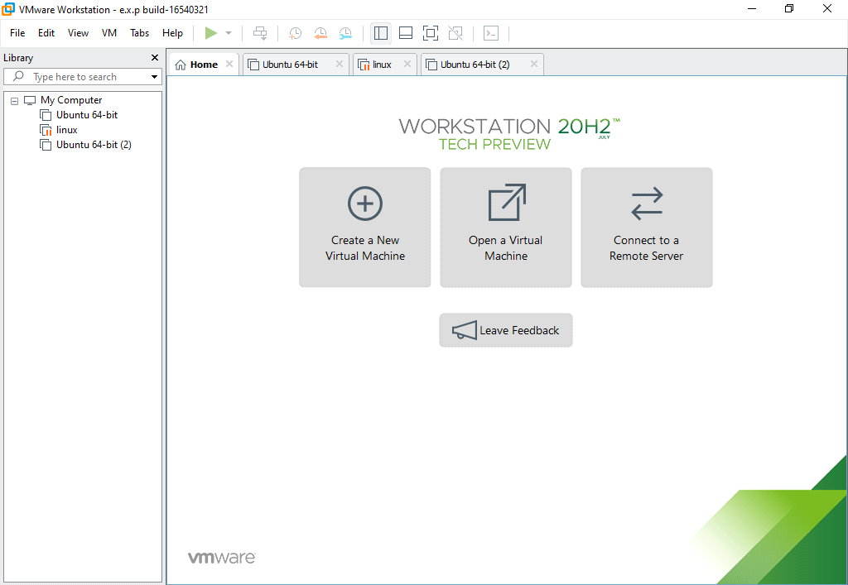

STEP 2: GO TO FILE AND SELECT NEW VIRTUAL MACHINE

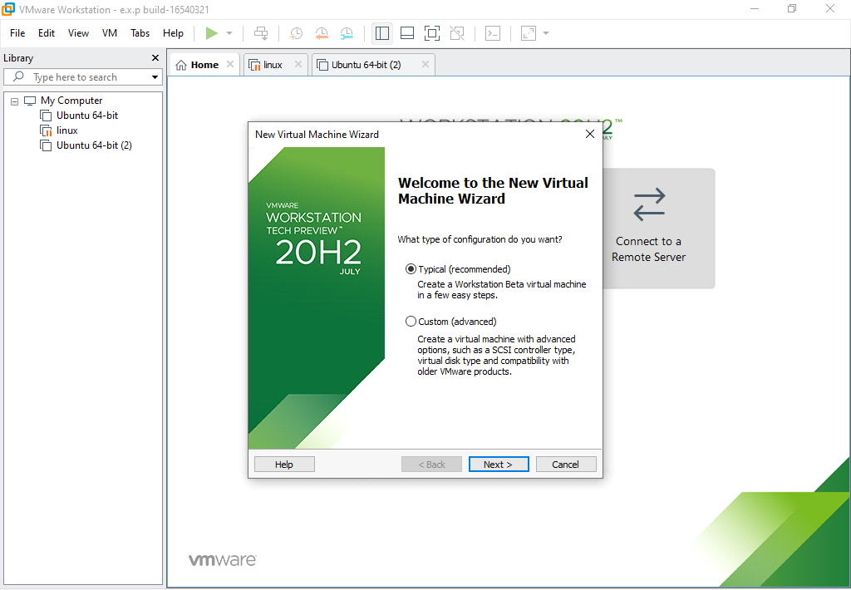

STEP 3: SELECT DISC IMAGE FILE

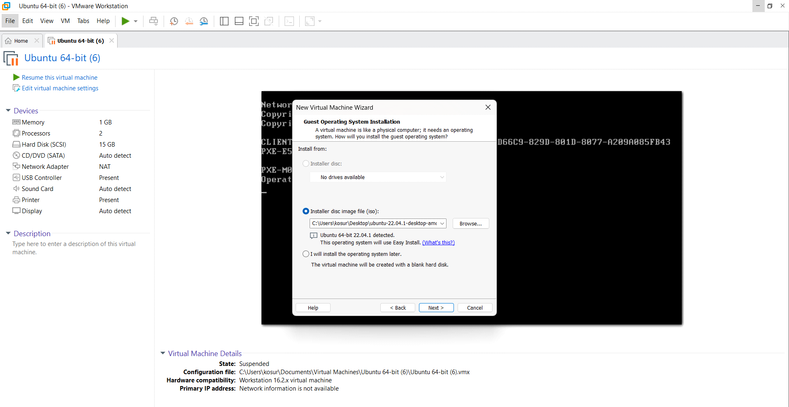

STEP 4:CHOOSE GUEST OPERATING SYSTEM AND VERSION

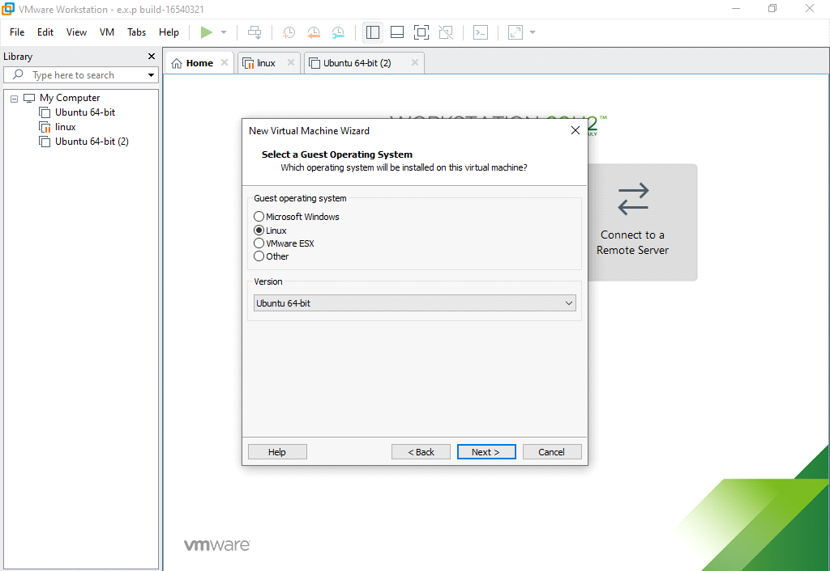

STEP 5: CHOOSE VIRTUAL MACHINE NAME AND LOCATION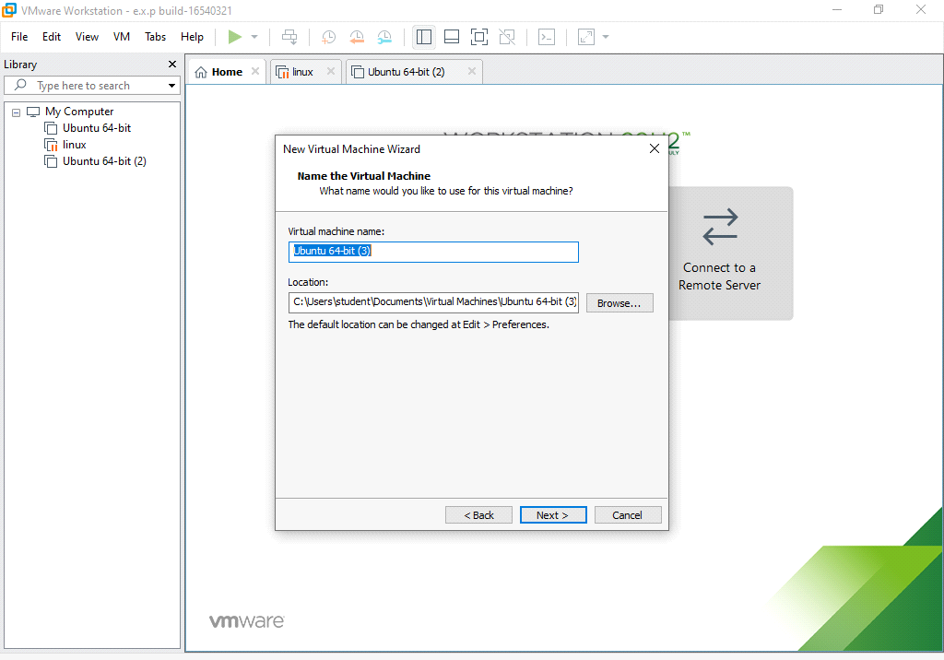STEP 6: SET MAXIMUM DISK SIZE AND STORE AS A SINGLE FILE

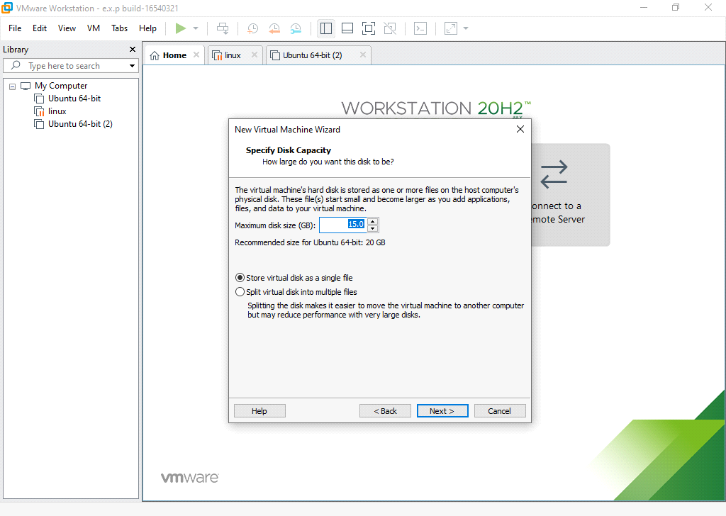

STEP 7:SET HARD DISK SIZE AND MEMORY

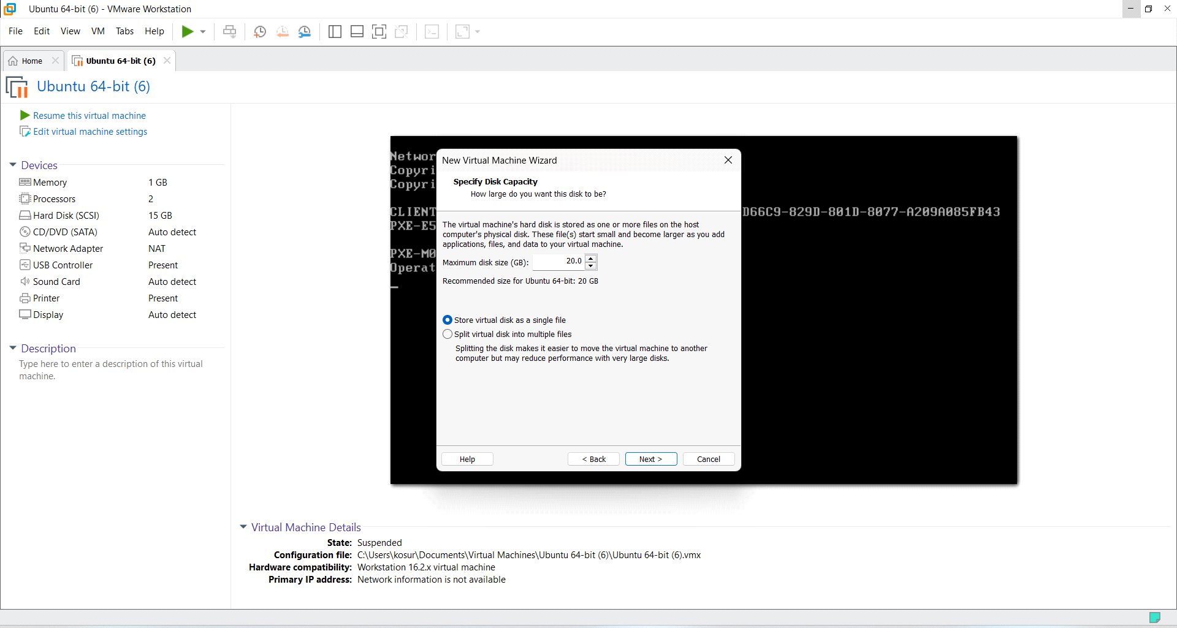

STEP 8:OUTPUT

